

**Smart Village Campus**

**Mechatronics Engineering**

**PID Optimization Problem (12th)**

**Optimum Design (ME554)**

**Created by:**

Adham Eid 20107315  
 Farida Ahmed Abdelsalam 20107458

**Prepared For:**

Dr Yasser El-shaer

# Table of contents

Table of contents 1

Problem formulation 3

Project description 3

Data and information collection 3

4

Definition of design variables 4

Optimization Criterion 4

Formulation of constraints 4

Solution 5

Method 1: (Adham) 5

Genetic Algorithm Method 5

Advantages and limitations 5

Justification 5

Settings 5

Results 5

Analysis 7

Genetic Algorithm + local search hybrid Method 7

Method 2: (Farida) 8

Particle swarm Optimization 8

Advantages and limitations 8

Justification 8

Settings 8

Matlab code 8

Results 13

Analysis 14

Particle swarm Optimization + Simulated Annealing Method 14

Advantages and limitations 14

Justification 15

Settings 15

Results 21

Analysis 22

# Problem formulation

## Project description

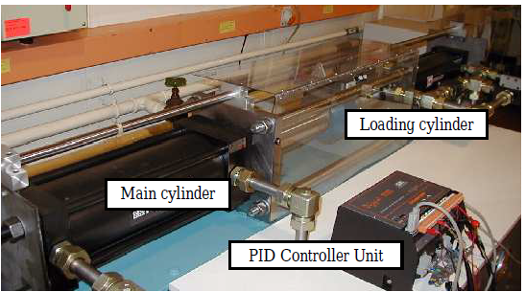The objective of this optimization problem is to work out the best values for a pid controller of a hydraulic position control system. The pid controller will regulate the 3-way promotional valve that controls the main and loading cylinder as shown in Figure 1. A nonlinear model of the 3-way valve has been derived from the actual physical model. This model can be used to predict the response of the physical system when given a step input. Without a controller, the system exhibits overshoot and some oscillation before it settles. A pid controller with its corresponding (kp, ki, kd) values is needed to minimize the overshoot, and to achieve a steady state error less than 5%, a settling time between 1 second and 1.5 seconds, and a rise time greater than 0.5 seconds. Minimizing the overshoot is essential because any overshoot in the response of the system will cause damage to the system. The rise time and settling time are chosen based on the characteristics of the 3-way proportional valve. Also, a low steady state error is needed to improve the repeatability of the system.

Figure

## Data and information collection

Equation 1, is the transfer function of the hydraulic system which is from a research paper [1]. Equation 2, is the transfer function of a standard PID controller. MATLAB has been used to calculate all the data that is needed like: Overshoot, rise time, settling time, and steady state error. Figure 2 shows the block diagram of the PID controller and the transfer function.

$G_{p}(s)=\frac{7.84}{3s^{2 }+5.04s+7.84}$ (1)

$PID(s) =K_{p }+\frac{K_{i}}{s}+K_{d}s$ (2)

## Definition of design variables

Figure

The values of the PID are identified as the design variables for this problem.

1. Kp = Proportional gain
2. Ki = Integral gain
3. Kd = Derivative component

## Optimization Criterion

The objective is to design a PID controller that minimizes overshoot.

$$f(K_{p}, K_{i}, K_{d})= Minimize (Overshoot)$$

## Formulation of constraints

Inequality constraints:

1. Steady-state error $≤ 5\%$
2. Settling time $≥ 1 Second$
3. Settling time $≤1.5 Seconds$
4. Rise time $≥ 0.5 Seconds$

# 

# Solution

## Method 1: (Adham)

### Genetic Algorithm Method

#### Advantages and limitations

Genetic algorithm is a search technique that tries to mimic natural selection and evolution. It can be used to solve both constrained and unconstrained problems. Some advantages include: its robustness because it is able to find global minimum or global maximum points. It can also take advantage of parallel processing. This means it can run more effectively on machines with many cpu cores. Genetic algorithms are also not affected by starting positions. It is also effective in searching in large solution spaces and lastly it doesn’t need any derivative information. Some limitations include: Long convergence times, sometimes premature convergence occurs because there isn’t a lot of diversity in evolution, so it gets stuck, and it won’t work well with complex fitness functions since it needs to calculate it for every population.

#### Justification

With all these limitations in mind, Genetic algorithm is still a suitable search method for this problem because, the fitness function is not complex, convergence times for this problem is not high, and lastly the search area is not large.

#### Settings

The following settings were used for the genetic algorithm: A population size of 800, Max generations of 300, Elite count of 8, Crossover fraction of 0.8, and mutation and parallel processing were turned on. The global optimization toolbox needed to use the genetic algorithm function. The parallel computing toolbox was needed to use the parallel feature in the ga function.

#### Results

The genetic algorithm only needed 4 generations to find a suitable solution. Info about the generations is shown in the figure []. The algorithm took **269.33** seconds to find the solution. 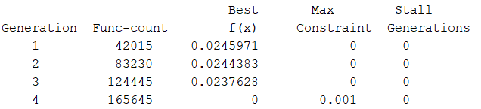

Figure shows the convergence graph.

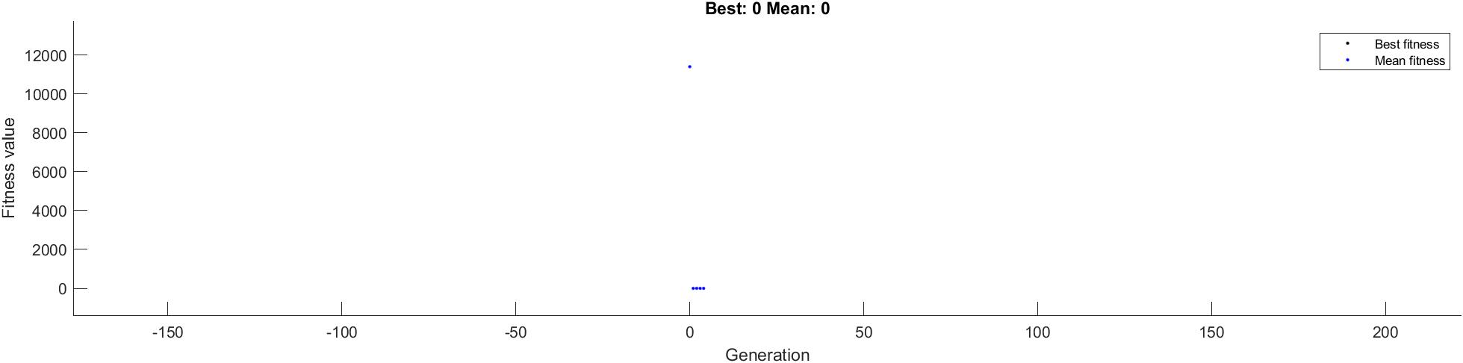

The solution from the genetic algorithm is:

* Kp = 2.4956
* Ki = 3.8180
* Kd = 1.4552

Figure shows the Rise time, settling time, Steady state error, and overshoot of the transfer function with and without the PID controller.

Figure shows a graph of the response of the transfer function to a step input with and without the PID controller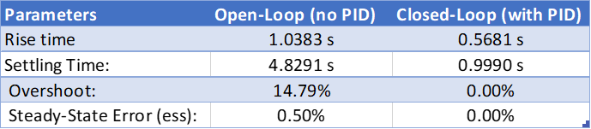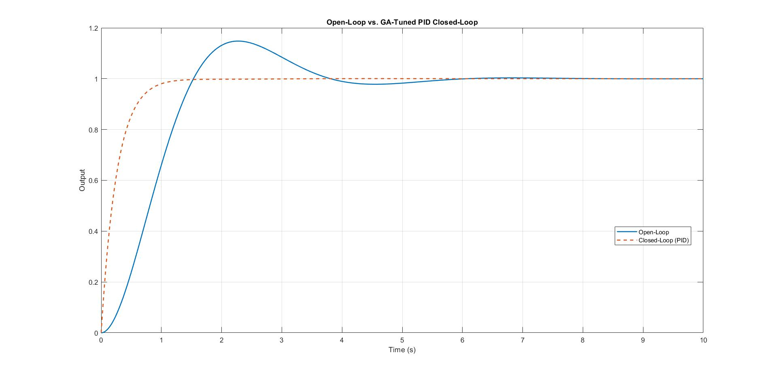

#### Analysis

The transfer function without any controller experiences nearly 15% overshoot and has very poor rise and settling time. After using the genetic algorithm to find the optimal values of the PID controller, it found that (Kp = 2.4956, Ki = 3.8180, Kd = 1.4552) these pid values minimizes the overshoot to 0 % and satisfies the rise time (with a rise time of 0.581 s), settling time (with a settling time of 0.999 s), and steady state error constraints (with a steady state error of 0%). It took 269.33 seconds to find the solution.

### Genetic Algorithm + local search hybrid Method

## Method 2: (Farida)

### Particle swarm Optimization

#### Advantages and limitations

Particle Swarm Optimization (PSO) is a stochastic optimization technique developed by James Kennedy and Russell Eberhart in 1995. It involves a group of particles moving through a solution space to find the optimum of an objective function. PSO balances exploration and exploitation, making it useful in engineering, machine learning, and control systems for solving nonlinear, multidimensional optimization problems.this method is an evolutionary algorithm that is simple to implement, with fewer parameters to adjust compared to other algorithms like Genetic Algorithms. It requires only a few control parameters, often converges faster than other optimization algorithms, and can be applied to a wide range of optimization problems. It also has parallelization capability, improving computation speed for large problems.

However, such method can get stuck at local minima , especially in complex or multimodal search spaces.Also,Performance of PSO depends on proper tuning of inertia weight and learning factors, with poor settings leading to instability or poor results. Scalability issues may degrade performance as problem dimensionality increases. Lack of diversity can reduce exploration ability and limit the algorithm's global optimum. pso does not guarantee convergence, especially without escape mechanisms.

#### Justification

Nevertheless , using PSO is quite suitable for solving this optimization problem as it can handle nonlinear and complex systems, eliminating the need for mathematical linearization or model derivatives. It is derivative-free, making it ideal for black-box system optimization. pso can be easily customized to handle multi-objective optimization, and it has global optimization capability, allowing for better performance in noisy systems. pso is also effective for systems with time delays due to fluid dynamics, as it doesn't rely on system time constants or frequency responses. Overall,pso offers a flexible and efficient solution for optimizing hydraulic systems.

#### Settings

The following settings were used for the PSO: Number of particles are 30, Max iterations of 100, Inertia weight that decays by 0.99 per iteration ,Cognitive coefficient (self-confidence) of 1.5 and Social coefficient (swarm confidence) of 1.5 .

#### Matlab code

% Standard PSO-PID Optimization for DC Motor Control

% Plant: Gp(s) = 0.067 / (0.00113s^2 + 0.0078854s + 0.0171)

clc**;**

clear**;**

close all**;**

%% DC Motor Transfer Function

num **=** 0.067**;**

den **=** **[**0.00113**,** 0.0078854**,** 0.0171**];**

motor_tf **=** tf**(**num**,** den**);**

%% PSO Parameters

n_particles **=** 30**;** % Number of particles

max_iter **=** 100**;** % Maximum iterations

w **=** 0.9**;** % Inertia weight

c1 **=** 1.5**;** % Cognitive coefficient

c2 **=** 1.5**;** % Social coefficient

Kp_range **=** **[**0**,** 50**];** % Range for Kp

Ki_range **=** **[**0**,** 50**];** % Range for Ki

Kd_range **=** **[**0**,** 10**];** % Range for Kd

%% Initialize particles

particles **=** struct**(**'position'**,** **[],** 'velocity'**,** **[],** 'cost'**,** **[],** 'best_position'**,** **[],** 'best_cost'**,** **[]);**

global_best**.**cost **=** inf**;**

global_best**.**position **=** **[];**

**for** i **=** 1**:**n_particles

% Random initialization within bounds

Kp **=** Kp_range**(**1**)** **+** **(**Kp_range**(**2**)-**Kp_range**(**1**))\***rand**();**

Ki **=** Ki_range**(**1**)** **+** **(**Ki_range**(**2**)-**Ki_range**(**1**))\***rand**();**

Kd **=** Kd_range**(**1**)** **+** **(**Kd_range**(**2**)-**Kd_range**(**1**))\***rand**();**

particles**(**i**).**position **=** **[**Kp**,** Ki**,** Kd**];**

particles**(**i**).**velocity **=** zeros**(**1**,** 3**);**

% Evaluate initial cost

**[**cost**,** **~,** **~,** steady_state_error**]** **=** evaluate_pid**([**Kp**,** Ki**,** Kd**],** motor_tf**);**

particles**(**i**).**cost **=** cost**;**

particles**(**i**).**best_position **=** particles**(**i**).**position**;**

particles**(**i**).**best_cost **=** cost**;**

% Update global best

**if** cost **<** global_best**.**cost

global_best**.**cost **=** cost**;**

global_best**.**position **=** particles**(**i**).**position**;**

**end**

**end**

%% PSO Optimization Loop

**for** iter **=** 1**:**max_iter

**for** i **=** 1**:**n_particles

% Update velocity

r1 **=** rand**(**1**,**3**);**

r2 **=** rand**(**1**,**3**);**

cognitive **=** c1 **\*** r1 **.\*** **(**particles**(**i**).**best_position **-** particles**(**i**).**position**);**

social **=** c2 **\*** r2 **.\*** **(**global_best**.**position **-** particles**(**i**).**position**);**

particles**(**i**).**velocity **=** w **\*** particles**(**i**).**velocity **+** cognitive **+** social**;**

% Update position

particles**(**i**).**position **=** particles**(**i**).**position **+** particles**(**i**).**velocity**;**

% Apply bounds

particles**(**i**).**position**(**1**)** **=** max**(**Kp_range**(**1**),** min**(**Kp_range**(**2**),** particles**(**i**).**position**(**1**)));**

particles**(**i**).**position**(**2**)** **=** max**(**Ki_range**(**1**),** min**(**Ki_range**(**2**),** particles**(**i**).**position**(**2**)));**

particles**(**i**).**position**(**3**)** **=** max**(**Kd_range**(**1**),** min**(**Kd_range**(**2**),** particles**(**i**).**position**(**3**)));**

% Evaluate new position

**[**cost**,** step_info**,** **~,** steady_state_error**]** **=** evaluate_pid**(**particles**(**i**).**position**,** motor_tf**);**

% Update personal best

**if** cost **<** particles**(**i**).**best_cost

particles**(**i**).**best_cost **=** cost**;**

particles**(**i**).**best_position **=** particles**(**i**).**position**;**

% Update global best

**if** cost **<** global_best**.**cost

global_best**.**cost **=** cost**;**

global_best**.**position **=** particles**(**i**).**position**;**

best_step_info **=** step_info**;**

best_steady_state_error **=** steady_state_error**;**

**end**

**end**

**end**

% Display progress

fprintf**(**'Iteration %d: Global Best score = %.4f, Kp=%.3f, Ki=%.3f, Kd=%.3f\n'**,** ...

iter**,** global_best**.**cost**,** global_best**.**position**(**1**),** global_best**.**position**(**2**),** global_best**.**position**(**3**));**

% Optional: Adaptive inertia weight

w **=** w **\*** 0.99**;**

**end**

%% Display Results

fprintf**(**'\nOptimization Results:\n'**);**

fprintf**(**'Best PID Parameters: Kp = %.3f, Ki = %.3f, Kd = %.3f\n'**,** ...

global_best**.**position**(**1**),** global_best**.**position**(**2**),** global_best**.**position**(**3**));**

% Get open-loop response metrics

**[**y_open**,** t_open**]** **=** step**(**motor_tf**);**

open_info **=** stepinfo**(**y_open**,** t_open**);**

ss_error_open **=** abs**(**1 **-** y_open**(end))** **\*** 100**;**

fprintf**(**'\n--- Scaled Open-Loop (no PID) ---\n'**);**

fprintf**(**'Rise Time: %.4f s\n'**,** open_info**.**RiseTime**);**

fprintf**(**'Settling Time:%.4f s\n'**,** open_info**.**SettlingTime**);**

fprintf**(**'Overshoot: %.2f%%\n'**,** open_info**.**Overshoot**);**

fprintf**(**'Steady-State Error: %.2f%%\n'**,** ss_error_open**);**

fprintf**(**'\n--- Closed-Loop (with PID) ---\n'**);**

fprintf**(**'Rise Time: %.4f s\n'**,** best_step_info**.**RiseTime**);**

fprintf**(**'Settling Time:%.4f s\n'**,** best_step_info**.**SettlingTime**);**

fprintf**(**'Overshoot: %.2f%%\n'**,** best_step_info**.**Overshoot**);**

fprintf**(**'Steady-State Error: %.2f%%\n'**,** best_steady_state_error**);**

% ... (previous code remains the same until the comparative plot section)

%% Comparative Plot: Open-Loop vs PID-Controlled

**[~,** **~,** sys_cl**]** **=** evaluate_pid**(**global_best**.**position**,** motor_tf**);**

% Calculate DC gain of open-loop system

DC_gain **=** dcgain**(**motor_tf**);**

% Create scaled open-loop system that settles at 1

scaled_open_loop **=** motor_tf**/**DC_gain**;**

figure**;**

set**(**gcf**,** 'Position'**,** **[**100**,** 100**,** 800**,** 500**]);**

% Simulate responses with consistent time vector

t **=** 0**:**0.001**:**2**;**

**[**y_open**,** t_open**]** **=** step**(**scaled_open_loop**,** t**);** % Using scaled open-loop

**[**y_pid**,** t_pid**]** **=** step**(**sys_cl**,** t**);**

% Plot both responses

plot**(**t_open**,** y_open**,** 'b'**,** 'LineWidth'**,** 2**);**

hold on**;**

plot**(**t_pid**,** y_pid**,** 'r'**,** 'LineWidth'**,** 2**);**

plot**([**0 t**(end)],** **[**1 1**],** 'k--'**,** 'LineWidth'**,** 1**);** % Reference line

hold off**;**

% Add labels and title

title**(**'System Response Comparison: Open-Loop vs PSO-Optimized PID'**,** 'FontSize'**,** 14**);**

xlabel**(**'Time (seconds)'**,** 'FontSize'**,** 12**);**

ylabel**(**'Amplitude'**,** 'FontSize'**,** 12**);**

legend**(**'Scaled Open-Loop Response'**,** 'PSO-Optimized PID'**,** 'Reference'**,** 'Location'**,** 'southeast'**);**

grid on**;**

% Set consistent axes

xlim**([**0 2**]);**

ylim**([**0 max**(**1.2**,** 1.2**\***max**([**y_open**;** y_pid**]))]);**

% Recalculate open-loop metrics with scaled system

**[**y_open_scaled**,** t_open_scaled**]** **=** step**(**scaled_open_loop**);**

open_info_scaled **=** stepinfo**(**y_open_scaled**,** t_open_scaled**);**

ss_error_open_scaled **=** abs**(**1 **-** y_open_scaled**(end))** **\*** 100**;**

%% Cost Function with Penalty Method

**function** **[**cost**,** step_info**,** sys_cl**,** steady_state_error**]** **=** evaluate_pid**(**pid_params**,** motor_tf**)**

Kp **=** pid_params**(**1**);**

Ki **=** pid_params**(**2**);**

Kd **=** pid_params**(**3**);**

% Create PID controller

pid_tf **=** pid**(**Kp**,** Ki**,** Kd**);**

% Closed-loop system

sys_cl **=** feedback**(**pid_tf **\*** motor_tf**,** 1**);**

% Get step response information

**try**

**[**y**,** t**]** **=** step**(**sys_cl**);**

step_info **=** stepinfo**(**sys_cl**);**

% Calculate steady-state error properly

steady_state_value **=** y**(end);**

steady_state_error **=** abs**(**1 **-** steady_state_value**)** **\*** 100**;** % in percentage

% Extract performance metrics

overshoot **=** step_info**.**Overshoot**;**

**if** isempty**(**overshoot**)**

overshoot **=** 0**;**

**end**

rise_time **=** step_info**.**RiseTime**;**

settling_time **=** step_info**.**SettlingTime**;**

% Objective: Minimize overshoot

base_cost **=** overshoot**;**

% Constraints with penalty functions

penalty **=** 0**;**

% Steady-state error < 5%

**if** steady_state_error **>=** 5

penalty **=** penalty **+** 1000 **+** **(**steady_state_error **-** 5**)^**2**;**

**end**

% Settling time between 1 and 1.5 sec

**if** settling_time **<** 1

penalty **=** penalty **+** 1000 **+** **(**1 **-** settling_time**)^**2**;**

**elseif** settling_time **>** 1.5

penalty **=** penalty **+** 1000 **+** **(**settling_time **-** 1.5**)^**2**;**

**end**

% Rise time at least 0.5 sec

**if** rise_time **<** 0.5

penalty **=** penalty **+** 1000 **+** **(**0.5 **-** rise_time**)^**2**;**

**end**

% Total cost

cost **=** base_cost **+** penalty**;**

**catch**

% If simulation fails (unstable system), assign high cost

cost **=** 1e6**;**

step_info**.**Overshoot **=** 100**;**

step_info**.**RiseTime **=** 0**;**

step_info**.**SettlingTime **=** 100**;**

steady_state_error **=** 100**;**

sys_cl **=** tf**(**1**,[**1 1**]);** % Dummy stable system

**end**

**end**

#### Results

The output for the PSO optimization was as follows

PID Gains: Kp = 1.124, Ki = 1.572, Kd = 0.318

The table below shows the difference between scaled open loop , standard pso and hybrid pso results

The figure below shows the graph of the response of the transfer function without PID ,with PSO and with PSO-SA PID.

|  |  |  |
| --- | --- | --- |
| **parameters** | **Open loop (no PID)** | **Standard PSO** |
| Rise time: | 1.0407s | 0.5404s |
| Settling time: | 4.9542s | 1.4189s |
| Overshoot: | 14.58% | 0.00% |
| Steady state error (ess): | 0.18% | 0.34% |

The figure below shows the graph of the response of the transfer function without PID and with PSO optimized PID.

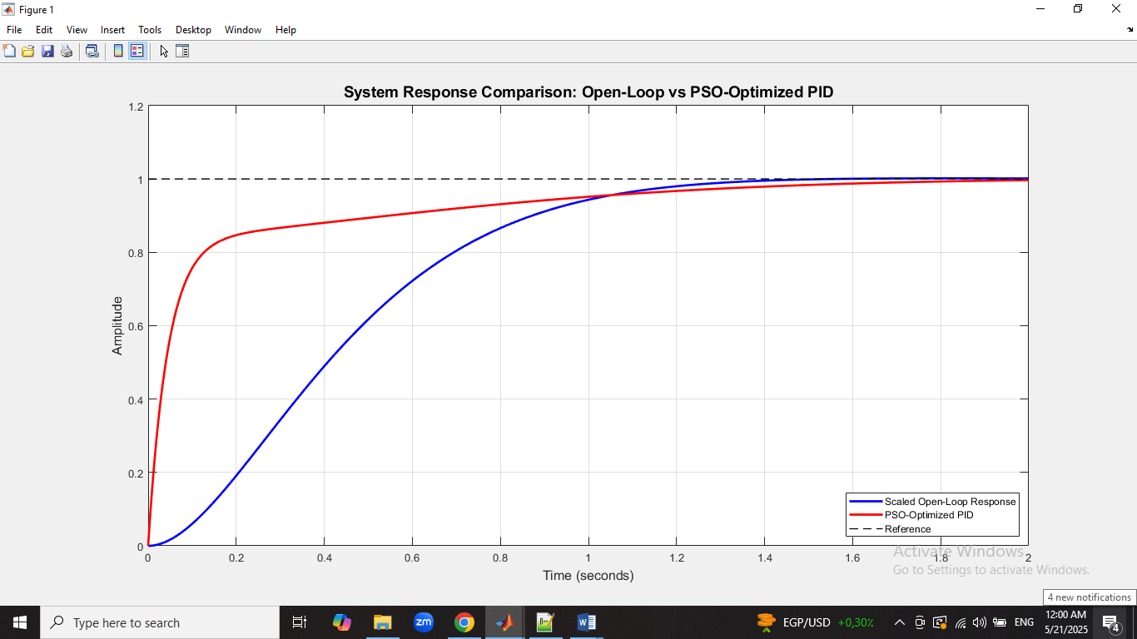

#### Analysis

The transfer function without any controller experiences 14.58% overshoot and has very poor rise and settling time. After using the standard PSO to find the optimal values of the PID controller, it found that (Kp = 1.124, Ki = 1.572, Kd = 0.318) these pid values minimizes the overshoot to 0 % , minimizes the rise time and settling time and satisfies steady state error constraint.

### Particle swarm Optimization + Simulated Annealing Method

#### Advantages and limitations

PSO with Simulated Annealing (PSO-SA) is a hybrid optimization algorithm that combines Particle Swarm Optimization's global search capability with Simulated Annealing's local refinement ability. It guides particles towards promising regions using personal and global best experiences, while Simulated Annealing introduces controlled random jumps to help particles escape local optima. PSO-SA offers several advantages, including improved global search capability, balanced exploration and exploitation, more robust convergence, effectiveness for nonlinear and noisy systems, and adaptive behavior. It helps PSO escape local minima, allowing for better convergence to the global optimum. The hybrid method reduces the risk of premature convergence, making it suitable for real-world control systems like hydraulic systems. Additionally, SA introduces temperature-dependent randomness, allowing occasional uphill moves to avoid traps in suboptimal regions.

However, the hybrid optimization method (SA) has several drawbacks, including increased computational cost, parameter tuning complexity, potential slow convergence, and implementation complexity. SA adds extra steps per iteration, making it slower than basic PSO, especially for large-scale problems. It also requires careful tuning of both parameters, which can slow down the optimization process if not properly tuned.

#### Justification

But using this hybrid method will improve the results of PSO optimization as PSO-SA is a robust solution for real-world hydraulic systems, overcoming sensor noise, load fluctuations, and external disturbances due to its non-gradient information requirement and stochastic acceptance of suboptimal solutions.PSO may struggle with suboptimal solutions due to swarm stagnation, but SA's thermal escape mechanism allows occasional uphill moves, enabling better-performing PID parameters.

#### Settings

The following settings were used for the simulated annealing:Cooling rate of 0.95 and the Number of SA iterations per PSO iteration is 5. The setting for the pso is the same as previously stated.

Matlab code

% Hybrid PSO-SA vs Standard PSO PID Optimization Comparison

% Plant: Gp(s) = 7.84 / (3s^2 + 5.04s + 7.84)

clc**;** clear**;** close all**;**

%% DC Motor Transfer Function

num **=** 7.84**;**

den **=** **[**3**,** 5.04**,** 7.84**];**

motor_tf **=** tf**(**num**,** den**);**

%% Common Parameters

n_particles **=** 30**;** % Number of particles

max_iter **=** 100**;** % Maximum iterations

Kp_range **=** **[**0**,** 50**];** % Range for Kp

Ki_range **=** **[**0**,** 50**];** % Range for Ki

Kd_range **=** **[**0**,** 10**];** % Range for Kd

%% 1. First run Standard PSO Optimization

disp**(**'Running Standard PSO Optimization...'**);**

w **=** 0.9**;** % Inertia weight

c1 **=** 1.5**;** % Cognitive coefficient

c2 **=** 1.5**;** % Social coefficient

% Initialize particles

particles **=** struct**(**'position'**,** **[],** 'velocity'**,** **[],** 'cost'**,** **[],** 'best_position'**,** **[],** 'best_cost'**,** **[]);**

pso_global_best**.**cost **=** inf**;**

pso_global_best**.**position **=** **[];**

**for** i **=** 1**:**n_particles

Kp **=** Kp_range**(**1**)** **+** **(**Kp_range**(**2**)-**Kp_range**(**1**))\***rand**();**

Ki **=** Ki_range**(**1**)** **+** **(**Ki_range**(**2**)-**Ki_range**(**1**))\***rand**();**

Kd **=** Kd_range**(**1**)** **+** **(**Kd_range**(**2**)-**Kd_range**(**1**))\***rand**();**

particles**(**i**).**position **=** **[**Kp**,** Ki**,** Kd**];**

particles**(**i**).**velocity **=** zeros**(**1**,** 3**);**

**[**cost**,** **~,** **~,** **~]** **=** evaluate_pid**([**Kp**,** Ki**,** Kd**],** motor_tf**);**

particles**(**i**).**cost **=** cost**;**

particles**(**i**).**best_position **=** particles**(**i**).**position**;**

particles**(**i**).**best_cost **=** cost**;**

**if** cost **<** pso_global_best**.**cost

pso_global_best**.**cost **=** cost**;**

pso_global_best**.**position **=** particles**(**i**).**position**;**

**end**

**end**

% PSO Optimization Loop

**for** iter **=** 1**:**max_iter

**for** i **=** 1**:**n_particles

r1 **=** rand**(**1**,**3**);**

r2 **=** rand**(**1**,**3**);**

particles**(**i**).**velocity **=** w **\*** particles**(**i**).**velocity **+** ...

c1 **\*** r1 **.\*** **(**particles**(**i**).**best_position **-** particles**(**i**).**position**)** **+** ...

c2 **\*** r2 **.\*** **(**pso_global_best**.**position **-** particles**(**i**).**position**);**

particles**(**i**).**position **=** particles**(**i**).**position **+** particles**(**i**).**velocity**;**

% Apply bounds

particles**(**i**).**position **=** max**([**Kp_range**(**1**),** Ki_range**(**1**),** Kd_range**(**1**)],** ...

min**([**Kp_range**(**2**),** Ki_range**(**2**),** Kd_range**(**2**)],** particles**(**i**).**position**));**

**[**cost**,** **~,** **~,** **~]** **=** evaluate_pid**(**particles**(**i**).**position**,** motor_tf**);**

**if** cost **<** particles**(**i**).**best_cost

particles**(**i**).**best_cost **=** cost**;**

particles**(**i**).**best_position **=** particles**(**i**).**position**;**

**if** cost **<** pso_global_best**.**cost

pso_global_best**.**cost **=** cost**;**

pso_global_best**.**position **=** particles**(**i**).**position**;**

**end**

**end**

**end**

w **=** w **\*** 0.99**;** % Inertia weight decay

**end**

% Get final PSO results

**[~,** pso_step_info**,** pso_sys_cl**,** pso_ss_error**]** **=** evaluate_pid**(**pso_global_best**.**position**,** motor_tf**);**

%% 2. Then run Hybrid PSO-SA Optimization

disp**(**'Running Hybrid PSO-SA Optimization...'**);**

w **=** 0.9**;** % Reset inertia weight

c1 **=** 1.5**;** % Cognitive coefficient

c2 **=** 1.5**;** % Social coefficient

% SA Parameters

T0 **=** 100**;** % Initial temperature

alpha **=** 0.95**;** % Cooling rate

sa_iter **=** 5**;** % SA iterations per PSO iteration

% Initialize particles (same initialization as PSO)

**for** i **=** 1**:**n_particles

Kp **=** Kp_range**(**1**)** **+** **(**Kp_range**(**2**)-**Kp_range**(**1**))\***rand**();**

Ki **=** Ki_range**(**1**)** **+** **(**Ki_range**(**2**)-**Ki_range**(**1**))\***rand**();**

Kd **=** Kd_range**(**1**)** **+** **(**Kd_range**(**2**)-**Kd_range**(**1**))\***rand**();**

particles**(**i**).**position **=** **[**Kp**,** Ki**,** Kd**];**

particles**(**i**).**velocity **=** zeros**(**1**,** 3**);**

**[**cost**,** **~,** **~,** **~]** **=** evaluate_pid**([**Kp**,** Ki**,** Kd**],** motor_tf**);**

particles**(**i**).**cost **=** cost**;**

particles**(**i**).**best_position **=** particles**(**i**).**position**;**

particles**(**i**).**best_cost **=** cost**;**

**if** cost **<** pso_global_best**.**cost

pso_global_best**.**cost **=** cost**;**

pso_global_best**.**position **=** particles**(**i**).**position**;**

**end**

**end**

% Hybrid PSO-SA Optimization Loop

T **=** T0**;** % Initial temperature

**for** iter **=** 1**:**max_iter

% Standard PSO Update

**for** i **=** 1**:**n_particles

r1 **=** rand**(**1**,**3**);**

r2 **=** rand**(**1**,**3**);**

particles**(**i**).**velocity **=** w **\*** particles**(**i**).**velocity **+** ...

c1 **\*** r1 **.\*** **(**particles**(**i**).**best_position **-** particles**(**i**).**position**)** **+** ...

c2 **\*** r2 **.\*** **(**pso_global_best**.**position **-** particles**(**i**).**position**);**

particles**(**i**).**position **=** particles**(**i**).**position **+** particles**(**i**).**velocity**;**

particles**(**i**).**position **=** max**([**Kp_range**(**1**),** Ki_range**(**1**),** Kd_range**(**1**)],** ...

min**([**Kp_range**(**2**),** Ki_range**(**2**),** Kd_range**(**2**)],** particles**(**i**).**position**));**

**[**cost**,** **~,** **~,** **~]** **=** evaluate_pid**(**particles**(**i**).**position**,** motor_tf**);**

**if** cost **<** particles**(**i**).**best_cost

particles**(**i**).**best_cost **=** cost**;**

particles**(**i**).**best_position **=** particles**(**i**).**position**;**

**if** cost **<** pso_global_best**.**cost

pso_global_best**.**cost **=** cost**;**

pso_global_best**.**position **=** particles**(**i**).**position**;**

**end**

**end**

**end**

% Simulated Annealing Local Search

**for** k **=** 1**:**sa_iter

**for** i **=** 1**:**n_particles

scale **=** **[(**Kp_range**(**2**)-**Kp_range**(**1**)),** **(**Ki_range**(**2**)-**Ki_range**(**1**)),** **(**Kd_range**(**2**)-**Kd_range**(**1**))];**

neighbor **=** particles**(**i**).**best_position **+** T**/**T0 **\*** randn**(**1**,**3**)** **.\*** **(**scale **/** 20**);**

neighbor **=** max**([**Kp_range**(**1**),** Ki_range**(**1**),** Kd_range**(**1**)],** ...

min**([**Kp_range**(**2**),** Ki_range**(**2**),** Kd_range**(**2**)],** neighbor**));**

**[**neighbor_cost**,** **~,** **~,** **~]** **=** evaluate_pid**(**neighbor**,** motor_tf**);**

delta_cost **=** neighbor_cost **-** particles**(**i**).**best_cost**;**

**if** delta_cost **<** 0 **||** rand**()** **<** exp**(-**delta_cost**/**T**)**

particles**(**i**).**best_position **=** neighbor**;**

particles**(**i**).**best_cost **=** neighbor_cost**;**

**if** neighbor_cost **<** pso_global_best**.**cost

pso_global_best**.**cost **=** neighbor_cost**;**

pso_global_best**.**position **=** neighbor**;**

**end**

**end**

**end**

**end**

T **=** alpha **\*** T**;** % Cool down temperature

w **=** w **\*** 0.99**;** % Inertia weight decay

**end**

% Get final PSO-SA results

**[~,** pso_sa_step_info**,** pso_sa_sys_cl**,** pso_sa_ss_error**]** **=** evaluate_pid**(**pso_global_best**.**position**,** motor_tf**);**

%% Display Comparison Results

% Scale open-loop to settle at 1

DC_gain **=** dcgain**(**motor_tf**);**

scaled_open_loop **=** motor_tf**/**DC_gain**;**

% Get open-loop response metrics

**[**y_open**,** t_open**]** **=** step**(**scaled_open_loop**);**

open_info **=** stepinfo**(**y_open**,** t_open**);**

ss_error_open **=** abs**(**1 **-** y_open**(end))** **\*** 100**;**

% Display all results

fprintf**(**'\n=== Complete Performance Comparison ===\n'**);**

fprintf**(**'\n--- Scaled Open-Loop (no PID) ---\n'**);**

fprintf**(**'Rise Time: %.4f s\n'**,** open_info**.**RiseTime**);**

fprintf**(**'Settling Time:%.4f s\n'**,** open_info**.**SettlingTime**);**

fprintf**(**'Overshoot: %.2f%%\n'**,** open_info**.**Overshoot**);**

fprintf**(**'Steady-State Error: %.2f%%\n'**,** ss_error_open**);**

fprintf**(**'\n--- Standard PSO Results ---\n'**);**

fprintf**(**'PID Gains: Kp = %.4f, Ki = %.4f, Kd = %.4f\n'**,** pso_global_best**.**position**);**

fprintf**(**'Rise Time: %.4f s\n'**,** pso_step_info**.**RiseTime**);**

fprintf**(**'Settling Time:%.4f s\n'**,** pso_step_info**.**SettlingTime**);**

fprintf**(**'Overshoot: %.2f%%\n'**,** pso_step_info**.**Overshoot**);**

fprintf**(**'Steady-State Error: %.2f%%\n'**,** pso_ss_error**);**

fprintf**(**'\n--- Hybrid PSO-SA Results ---\n'**);**

fprintf**(**'PID Gains: Kp = %.4f, Ki = %.4f, Kd = %.4f\n'**,** pso_global_best**.**position**);**

fprintf**(**'Rise Time: %.4f s\n'**,** pso_sa_step_info**.**RiseTime**);**

fprintf**(**'Settling Time:%.4f s\n'**,** pso_sa_step_info**.**SettlingTime**);**

fprintf**(**'Overshoot: %.2f%%\n'**,** pso_sa_step_info**.**Overshoot**);**

fprintf**(**'Steady-State Error: %.2f%%\n'**,** pso_sa_ss_error**);**

%% Triple Comparison Plot

figure**;**

set**(**gcf**,** 'Position'**,** **[**100**,** 100**,** 1000**,** 700**]);**

% Simulate all responses with consistent time vector

t **=** 0**:**0.01**:**10**;**

**[**y_open_scaled**,** **~]** **=** step**(**scaled_open_loop**,** t**);**

**[**y_pso**,** **~]** **=** step**(**pso_sys_cl**,** t**);**

**[**y_pso_sa**,** **~]** **=** step**(**pso_sa_sys_cl**,** t**);**

% Plot all responses

plot**(**t**,** y_open_scaled**,** 'Color'**,** **[**0 0.5 0**],** 'LineWidth'**,** 2**);** % Dark green for open-loop

hold on**;**

plot**(**t**,** y_pso**,** 'b'**,** 'LineWidth'**,** 2**);** % Blue for PSO

plot**(**t**,** y_pso_sa**,** 'r'**,** 'LineWidth'**,** 2**);** % Red for PSO-SA

plot**([**0 t**(end)],** **[**1 1**],** 'k--'**,** 'LineWidth'**,** 1**);** % Reference line

hold off**;**

% Format plot

title**(**'System Response Comparison: Open-Loop vs PSO vs PSO-SA PID'**,** 'FontSize'**,** 16**);**

xlabel**(**'Time (seconds)'**,** 'FontSize'**,** 14**);**

ylabel**(**'Amplitude'**,** 'FontSize'**,** 14**);**

legend**(**'Scaled Open-Loop'**,** 'Standard PSO PID'**,** 'Hybrid PSO-SA PID'**,** 'Reference'**,** 'Location'**,** 'southeast'**);**

grid on**;**

xlim**([**0 10**]);**

ylim**([**0 1.2**]);**

%% Cost Function with Penalty Method

**function** **[**cost**,** step_info**,** sys_cl**,** steady_state_error**]** **=** evaluate_pid**(**pid_params**,** motor_tf**)**

Kp **=** pid_params**(**1**);**

Ki **=** pid_params**(**2**);**

Kd **=** pid_params**(**3**);**

t **=** 0**:**0.01**:**10**;**

pid_tf **=** pid**(**Kp**,** Ki**,** Kd**);**

sys_cl **=** feedback**(**pid_tf **\*** motor_tf**,** 1**);**

**try**

**[**y**,** t**]** **=** step**(**sys_cl**);**

step_info **=** stepinfo**(**sys_cl**);**

steady_state_value **=** y**(end);**

steady_state_error **=** abs**(**1 **-** steady_state_value**)** **\*** 100**;**

overshoot **=** step_info**.**Overshoot**;**

**if** isempty**(**overshoot**),** overshoot **=** 0**;** **end**

rise_time **=** step_info**.**RiseTime**;**

settling_time **=** step_info**.**SettlingTime**;**

base_cost **=** 0.5 **\*** overshoot **+** 0.8 **\*** settling_time **+** 0.7 **\*** rise_time**;**

penalty **=** 0**;**

**if** steady_state_error **>=** 5

penalty **=** penalty **+** 1000 **+** **(**steady_state_error **-** 5**)^**2**;**

**end**

**if** settling_time **<** 1

penalty **=** penalty **+** 1000 **+** **(**1 **-** settling_time**)^**2**;**

**elseif** settling_time **>** 1.5

penalty **=** penalty **+** 1000 **+** **(**settling_time **-** 1.5**)^**2**;**

**end**

**if** rise_time **<** 0.5

penalty **=** penalty **+** 5000 **+** 1000 **\*** **(**0.5 **-** rise_time**)^**2**;**

**end**

cost **=** base_cost **+** penalty**;**

**catch**

cost **=** 1e6**;**

step_info**.**Overshoot **=** 100**;**

step_info**.**RiseTime **=** 0**;**

step_info**.**SettlingTime **=** 100**;**

steady_state_error **=** 100**;**

sys_cl **=** tf**(**1**,[**1 1**]);**

**end**

**end**

#### Results

The output for the PSO-SA optimization was as follows

PID Gains: Kp = 2.8309, Ki = 4.3907, Kd = 1.7615

The table below shows the difference between scaled open loop , standard pso and hybrid pso results

|  |  |  |  |
| --- | --- | --- | --- |
| **parameters** | **Open loop (no PID)** | **Standard PSO** | **Hybrid PSO-SA** |
| Rise time: | 1.0407s | 0.6190s | 0.5003s |
| Settling time: | 4.9542s | 1.0000s | 1.0006s |
| Overshoot: | 14.58% | 0.00% | 0.00% |
| Steady state error (ess): | 0.18% | 0.25% | 0.34% |

The figure below shows the graph of the response of the transfer function without PID ,with PSO and with PSO-SA PID.

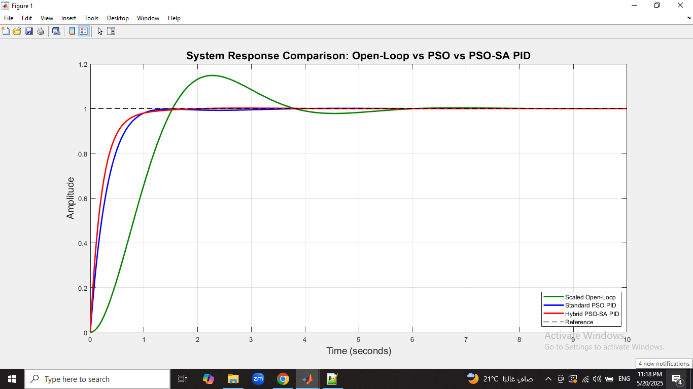

#### Analysis

After using the hybrid PSO to find the optimal values of the PID controller, it found that (Kp = 2.8309, Ki = 4.3907, Kd = 1.7615) these pid values minimizes the overshoot to 0 % and decreases the rise time even more than the standard pso and satisfies the settling time and steady state error constraints.

References

[1] *Optimal-tuning PID controller design for hydraulic position control systems*. (2001, September 1). IEEE Conference Publication | IEEE Xplore. https://ieeexplore.ieee.org/document/7076000